Kamchatka - My Native Land.

1. Fill in the gaps with the missing remarks.

Mr. White: How do you do ?
Tourist:.......
Mr. White: I wonder, where are you from?
T.:........
Mr. White: Is our region beautiful?
T.:........
Mr. White: Do you like our town?
T.:.......

2. Look at the picture. Would you like to visit this region? Why?
See the application № 6.

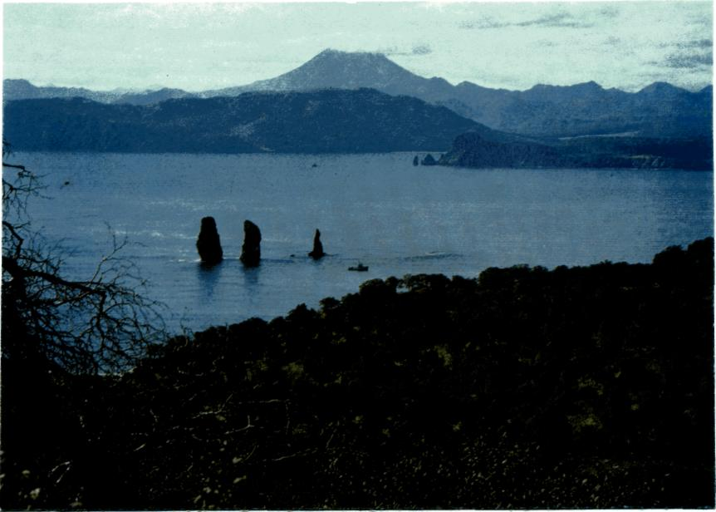

3. Look through the data on tourism in Kamchatka

- Kamchatka had 2 thousand visitors in 1992 and 30 thousand in 2004.
- The population of Petropavlovsk-Kamchatskiy is about 180 thousand.
- Seventy per cent of the visitors to the town are foreigners.
- The tourism industry is worth two thirds of money to budget a year.
- The tourism industry supports 1,5 000 jobs.
- Kamchatka has 10 museums and galleries.

How do you think tourism influences the life of population of the peninsula?

4. Study new words

-native land- родной край
-the peninsula- полуостров
-to stretch for- простираться на
-census- перепись населения
-inhabit- населять
-evens- эвены
-chukchi- чукчи
-koryaks- коряки
-ittelmens- ительмены
-develop- развивать
- fishery- рыболовство
-the main branch of industry- основная отрасль промышленности
-coast- побережье
-to be washed by- омываться
-timber- лес
-woodworking- лесоперерабатывающая
-coal-mining- добыча угля
-cattle-farming- скотоводство
-poultry-farming- птицеводство
-places of interest- интересные места, достопримечательности
-packet-boats- пакетбот
-in honour of- в честь

5. Read the story of the medical school student about his native land
and do the tasks after the text.

I'd like to tell you about my native land, which is called the peninsula of Kamchatka. Our peninsula is situated in the very eastern part of Russia. The territory of Kamchatka is about 470 thousand sq.kms. It stretches for 1.200 kms. from the north to the south. The population of Kamchatskaya region is about 240.000 people. There was no general census of population in our region for a long time, so the figures are not exact. People of different nationalities inhabit our peninsula. Among them there are many native people such as: evens, chukchi, koryaks, ittelmens and others, in other words Kamchatka is a multinational region. Kamchatka is also a very rich region, many industries are developed there. We cannot but mention about fishery because it is considered to be the main brunch of industry. As we know the coasts of Kamchatka are washed by seas and the Pacific Ocean from different sides. The other main industries are: crab-fishing, ship repairing, timber, woodworking, coal-mining and others. As far as agriculture there is vegetable growing, cattle farming, dairy-farming, poultry-farming and reindeer breeding and others on the peninsula. Petropavlovsk is the capital of Kamchatskaya region. It's an administrative, industrial, political and cultural center of Kamchatka. The population of Petropavlovsk is about 180.000 people. There are many places of interest in Petropavlovsk, such as: the monument of Vitus Bering, the Maksutov's battery, the historical museum, the regional library and many others. The history of the town is long and interesting. It was in 1740 when two packet-boats St.Peter and St.Paul came into the Avacha Bay under the command of V. Bering and a small village was built on the shore. And in honour of these two packet-boats our town has got the name of Petropavlovsk. And finishing up my story I'd like to add that I like my town and our peninsula because I was born there, and it's my native land. Petropavlovsk is also considered to be the advanced post of Russia and I am proud of it.

6. Find in the text English equivalents for the following.

- называется полуостровом
- самая восточная часть
- общая перепись населения
- цифры не точны
- люди различных национальностей
- коренные жители
- другими словами
- многонациональный регион
- нельзя не упомянуть
- считается главной отраслью промышленности
- небольшая деревня была построена на берегу
- форпост России

7. Use the words from Ex.3 to translate the underlined phrases in
these sentences

- Территория этого края простирается на многие сотни километров.
- Ительмены и коряки считают Камчатку родным краем.
- Много национальностей населяют этот край, поэтому он считается
многонациональным.
- Основная отрасль экономики региона - рыбная промышленность.
-Туристы приезжают на полуостров, чтобы посмотреть его
достопримечательности.
- Столица полуострова получила своё название в честь двух
пакетботов.

8. Find in the text the following

1. The hints that help you to understand what climate in Kamchatka is.
2. The things that make Kamchatka attractive for tourists.
3. The reason for considering Kamchatka a very rich and prospering region.
4. Kamchatka has long and rich history.

9. a) Express your regret following the example. Use “If only…+
Ved2”
Example: If only there were more interesting roots.
1. There are few tourists from Russia to Kamchatka.
2. The roads of Petropavlovsk-Kamchatskiy are not good enough.
3. The country lacks stability.
4. The main street lamps are not lit at night.
5. Not all Russians can afford to travel to Kamchatka.

b) Your friend might regret the following things. Express his
regret according to the example. Use “If only…+had+Ved3”

Example: If only the authorities had supported the development of fishing
industry.

1. Foreign tourists seldom come to Viluchinsk.
2. The authorities didn’t renovate the monuments.
3. The government didn’t invest enough money in the development of tourism
in Kamchatka.
4. Good shopping and parking facilities are not provided on the peninsula.
5. The tourist agency “Putnic” produced a low quality booklet about the town.

10. Complete the sentences using anything but ( что угодно, только
не… )

1. “Your so-called interesting root is…!”
2. “What? Another excursion?...”
3. “This church is a masterpiece, you say? It is…”
4. “Can’t say I feel attracted by the looks of the streets…”
5. Please do not take us there. We are…”

11. Choose any sentence from this exercise, expand it and exchange
your ideas with your class mates.

12. In pairs exchange your ideas about the following.
Use “…might\may…”, “probably”, “It’s quite possible
that” in your answers

- What would you recognize as a “brand” of Kamchatka?
- What is the influence of the washing seas and the ocean?
- What do you think about the growth of population of Kamchatka?
- What other places of interest in Petropavlovsk do you know?
- What makes Kamchatka unique?
- What are the roots of this uniqueness?

13. Prove that

- Kamchatka is a multinational region.
- Kamchatka is a very rich region.
- Kamchatka is attractive for tourists.
- the history of the town is long and interesting.
- Petropavlovsk is the advanced post of Russia.
- Kamchatka is worth seeing.

14. Make a list of features which can make your region attractive to
tourists.

- architectural monuments
- historic sites
- landscape
- cultural life
- sports facilities
- museums and exhibitions
- others

Using What You’ve Learned
1. Continue the list of things that, in your opinion, are needed to make
your region attractive as tourist destination and tell it to your classmates.

2. Imagine that you are a guide. Your task is to tell your tourists the most
interesting and amazing information about your native land.

2. Choose an event in history of your region or from life of a famous person of
Kamchatka that you would like to know more about. Do some research on
this event or person. You may want to ask a fellow classmate, a friend, a co-
worker, or a teacher for help or additional information. At another class
meeting, give a brief report telling what you learned and how you found the
information.

